1.Get the ids of games that can be played on every platform.

SELECT G.GAME_ID

FROM XGAMES G

WHERE NOT EXISTS

(SELECT P.*

FROM XPLATFORMS P

WHERE NOT EXISTS

(SELECT PL.*

FROM XPLAYS PL

WHERE G.GAME_ID = PL.GAME_ID

AND PL.PLATFORM_ID = P.PLATFORM_ID));

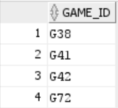

Cardinality: 4

2.Get the ids of developers that only develop 'Action-Adventure' games.

SELECT D.DEVELOPER_ID

FROM XDEVELOPERS D

WHERE D.DEVELOPER_ID NOT IN

(SELECT DV.DEVELOPER_ID

FROM XDEVELOPS DV

WHERE DV.GAME_ID NOT IN

(SELECT G.GAME_ID

FROM XGAMES G

WHERE G.GAME_GENRE = 'Action-Adventure'));

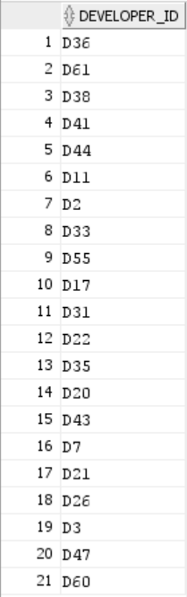

Cardinality: 21

3.Get the ids of cast members that are cast in none of the games with a price greater than 39.99.

SELECT C.CAST_ID

FROM XCASTMEMBERS C

WHERE C.CAST_ID IN

(SELECT CA.CAST_ID

FROM XCASTS CA

WHERE CA.GAME_ID NOT IN

(SELECT G.GAME_ID

FROM XGAMES G

WHERE G.GAME_PRICE > 39.99));

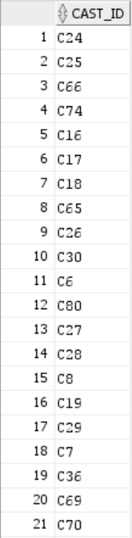

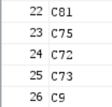

Cardinality: 26

4.Get the names and locations of all publishers, along with the names and headquarters of the developers they own, if any.

SELECT P.PUBLISHER_NAME, P.PUBLISHER_LOCATION, D.DEVELOPER_NAME, D.DEVELOPER_HQ

FROM XPUBLISHERS P LEFT JOIN XDEVELOPERS D ON

P.PUBLISHER_ID = D.PUBLISHER_ID;

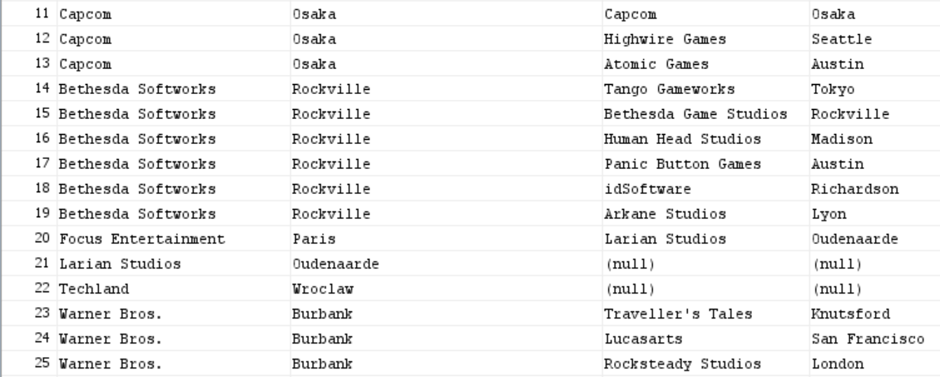

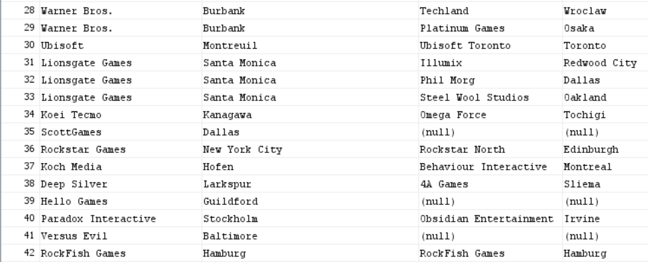

Cardinality: 68

5.Get the number of copies sold and genres of all video games, along with the rating scores they received and the ids of the reviewers that rated them, if any.

SELECT DISTINCT R.REVIEWER_ID, R.RATE_SCORE, G.GAME_COPIES, G.GAME_GENRE

FROM XRATES R RIGHT JOIN XGAMES G ON

R.GAME_ID = G.GAME_ID;

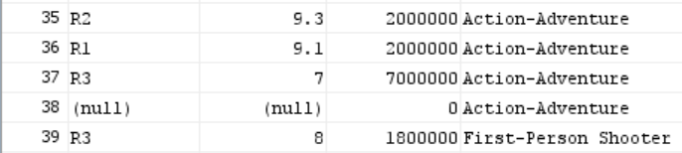

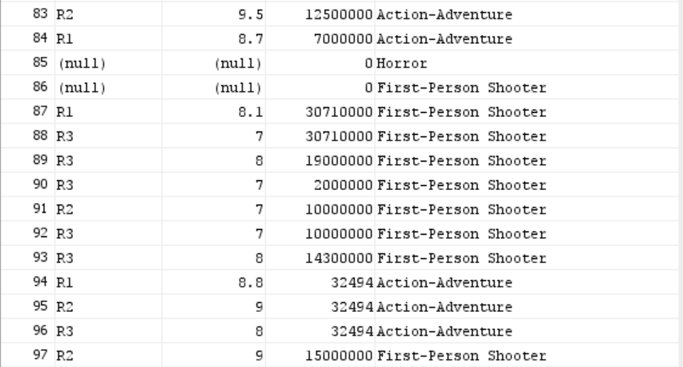

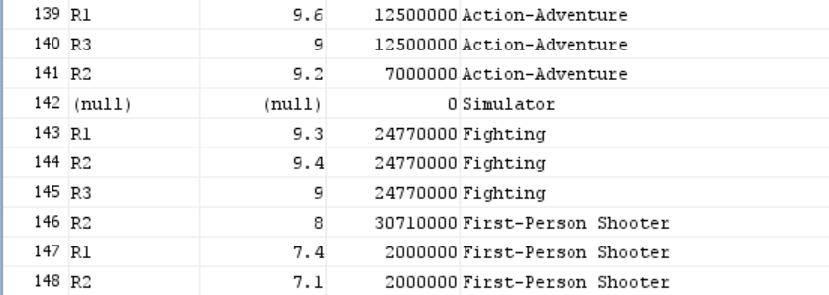

Cardinality: 217

6.Get the names and ages of all cast members along with the names and prices of video games they were cast in, if any, and include names and prices of all video games along with the names and ages of the cast members they cast, if any.

SELECT C.CAST_NAME, C.CAST_AGE, G.GAME_NAME, G.GAME_PRICE

FROM XCASTMEMBERS C FULL JOIN XCASTS CA ON

C.CAST_ID = CA.CAST_ID FULL JOIN XGAMES G ON

CA.GAME_ID = G.GAME_ID;

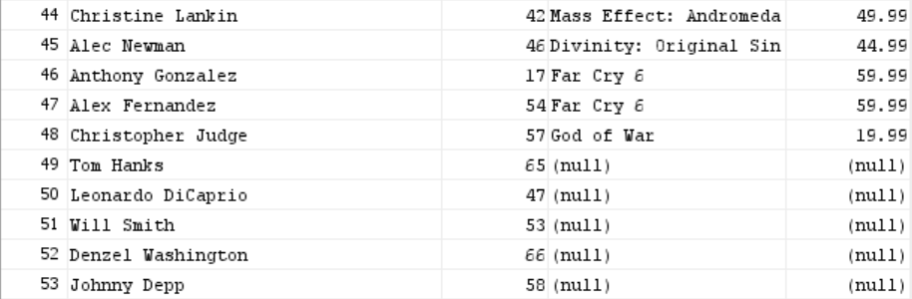

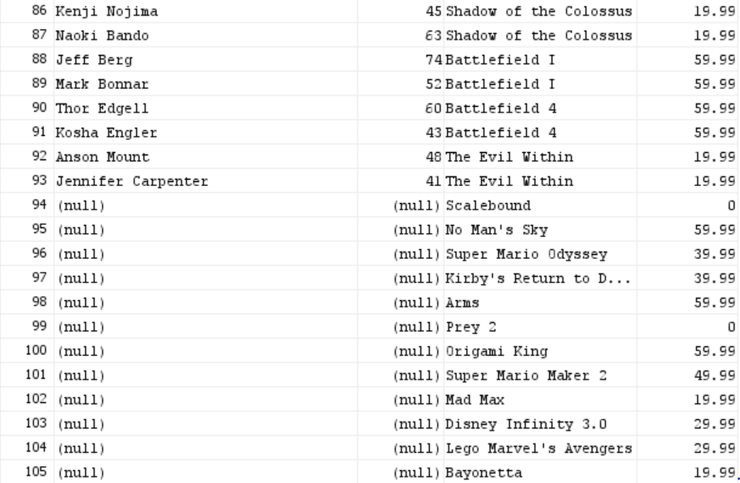

Cardinality: 142

7.Get the names of reviewers along with the rating scores of games that were given a score of less than 8 and created by a developer owned by a publisher located in Santa Monica.

SELECT DISTINCT R.REVIEWER_NAME, RA.RATE_SCORE

FROM XREVIEWERS R, XRATES RA, XGAMES G, XDEVELOPS DV, XDEVELOPERS D, XPUBLISHERS P

WHERE R.REVIEWER_ID = RA.REVIEWER_ID

AND RA.GAME_ID = G.GAME_ID

AND G.GAME_ID = DV.GAME_ID

AND DV.DEVELOPER_ID = D.DEVELOPER_ID

AND D.PUBLISHER_ID = P.PUBLISHER_ID

AND RA.RATE_SCORE < 8

AND P.PUBLISHER_LOCATION = 'Santa Monica';

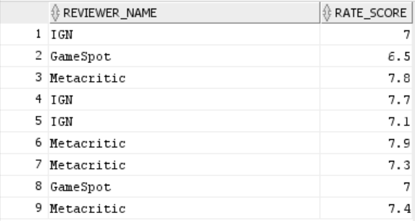

Cardinality: 9

8.Get the total number of games that can be played on consoles maintained by Nintendo.

SELECT COUNT(DISTINCT GAME_NAME) AS TOTAL_GAMES

FROM XGAMES G, XPLAYS P, XPLATFORMS PL, XMANUFACTURERS M

WHERE G.GAME_ID = P.GAME_ID

AND P.PLATFORM_ID = PL.PLATFORM_ID

AND PL.MANUFACTURER_ID = M.MANUFACTURER_ID

AND M.MANUFACTURER_NAME = 'Nintendo';



Cardinality: 1

9.Get the prices and the number of units sold for platforms that play games that have cast members whose age is greater than that of Troy Baker.

SELECT DISTINCT PLATFORM_PRICE, PLATFORM_UNITS

FROM XPLATFORMS PL, XPLAYS P, XGAMES G, XCASTS CA, XCASTMEMBERS C

WHERE PL.PLATFORM_ID = P.PLATFORM_ID

AND P.GAME_ID = G.GAME_ID

AND G.GAME_ID = CA.GAME_ID

AND CA.CAST_ID = C.CAST_ID

AND C.CAST_AGE >

(SELECT CM.CAST_AGE

FROM XCASTMEMBERS CM

WHERE CM.CAST_NAME = 'Troy Baker');

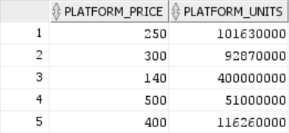

Cardinality: 5

10.Get the ids, names, and countries of manufacturers whose platforms play games that were developed and published by companies in the same location.

SELECT DISTINCT M.MANUFACTURER_ID, M.MANUFACTURER_NAME, M.MANUFACTURER_COUNTRY

FROM XMANUFACTURERS M, XPLATFORMS P, XPLAYS PL, XGAMES G, XDEVELOPS DV, XDEVELOPERS D, XPUBLISHERS P, XPUBLISHES PB

WHERE M.MANUFACTURER_ID = P.MANUFACTURER_ID

AND P.PLATFORM_ID = PL.PLATFORM_ID

AND PL.GAME_ID = G.GAME_ID

AND G.GAME_ID = DV.GAME_ID

AND G.GAME_ID = PB.GAME_ID

AND DV.DEVELOPER_ID = D.DEVELOPER_ID

AND PB.PUBLISHER_ID = P.PUBLISHER_ID

AND D.DEVELOPER_HQ = P.PUBLISHER_LOCATION;

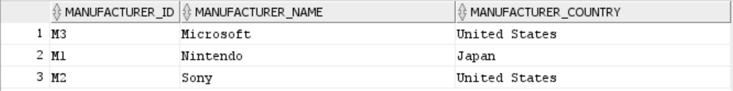

Cardinality: 3